CHAMPAGNE SERIES
NORTH CAPE YACHT CLUB

Sailing Instructions
MAY 20 & 21, 2023

1. Rules: This regatta will be governed by the current Racing Rules of Sailing of the United States Sailing Association, and by these Sailing Instructions.
2. Notices to Competitors: Notices to competitors will be posted on the notice board located outside the main doors of NCYC.
3. Signals Made Ashore: Signals made ashore will be displayed from the flagpole located between the NCYC clubhouse and the entry channel to the marina. If a postponement is signaled ashore, the warning signal will be made not less than 45 minutes after AP is lowered.
4. Schedule: There will be NO skipper’s meeting. The warning signal for the races will be at 9:55 hrs. on Saturday, May 20, 2023, and 9:55 hrs. on Sunday, May 21, 2023. Classes will be started at approximately 5-minute intervals. Class splits and starting order will be posted on the official notice board no later than 9:00 hrs. on May 20, 2023.
5. Classes: Class flag colors are as follows:
PHRF B – Number Code Flag #2 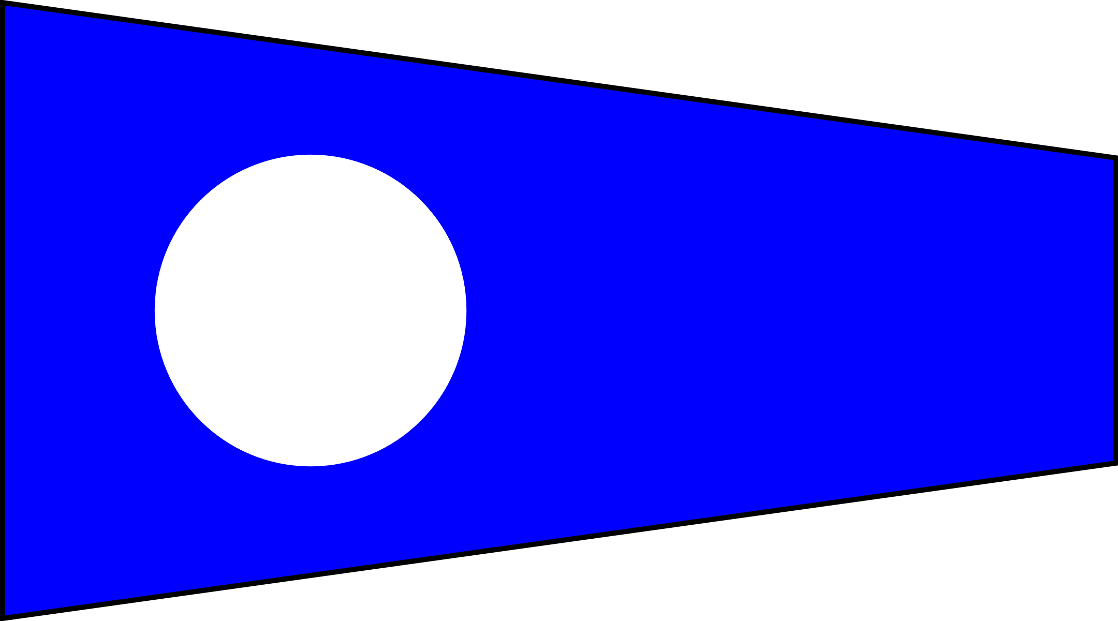
PHRF A – Number Code Flag #3 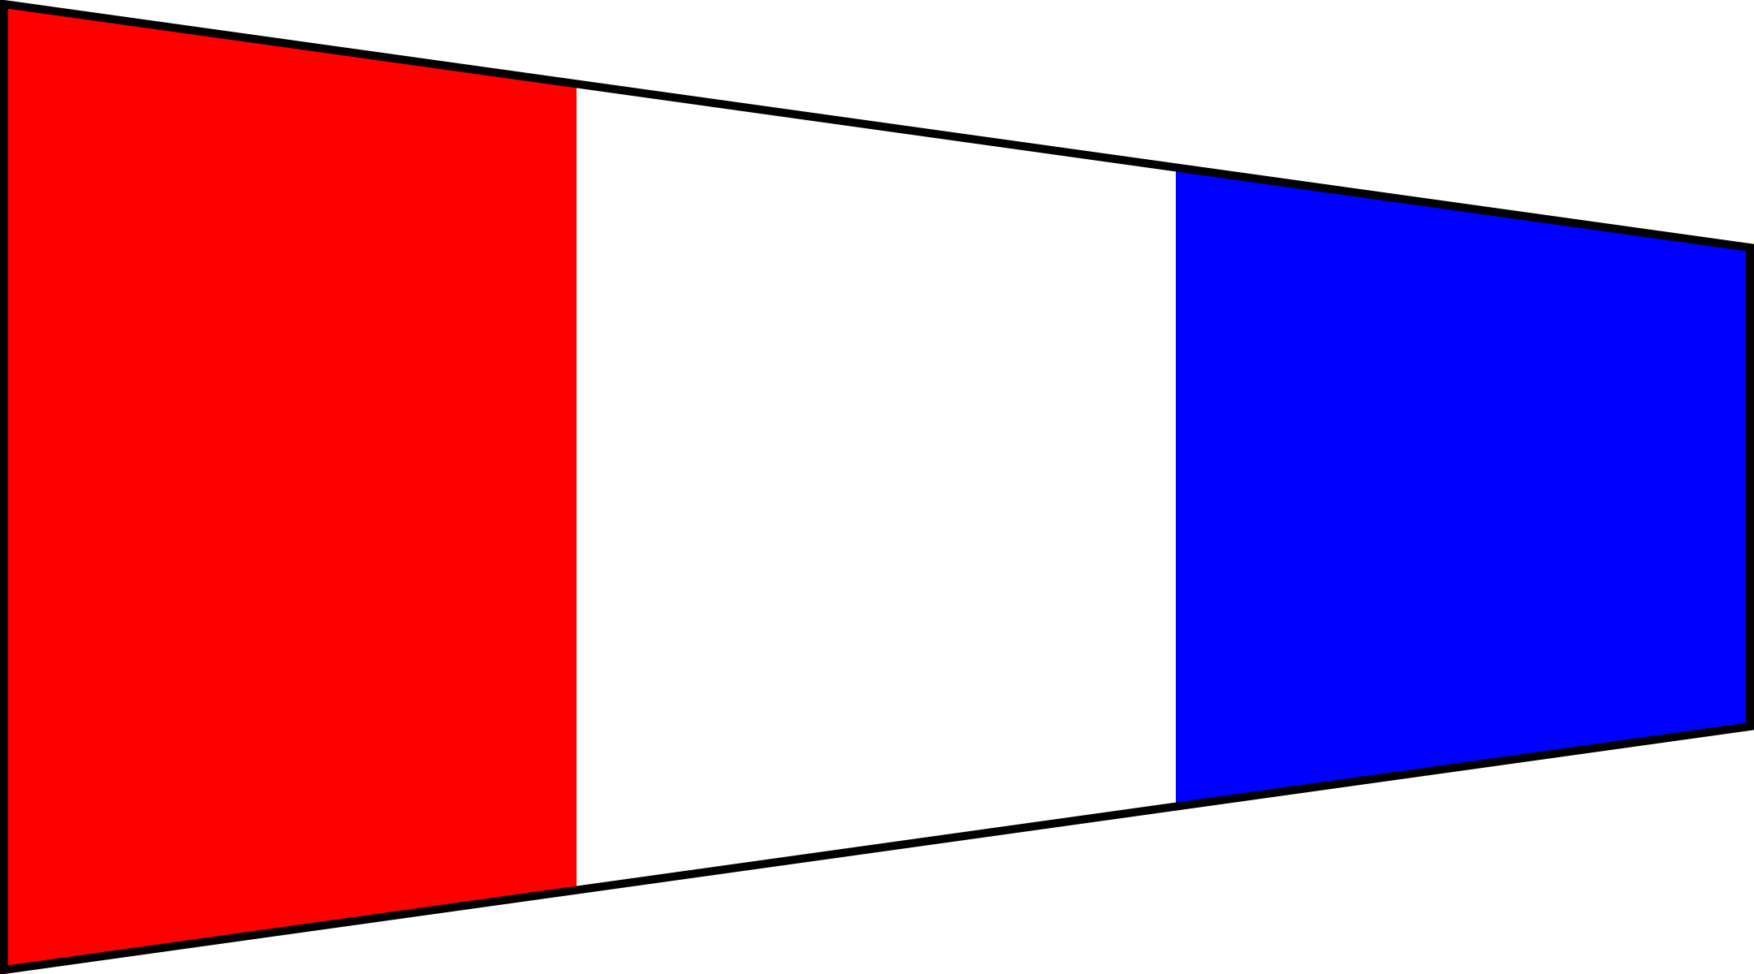
JAM – Number Code Flag #6
6. Racing Area: The racing area will be western Lake Erie, with the starting and finishing line at the NCYC Center mark approximately 2.4 nm east of the NCYC entry channel.
7. Start and Finish: The Start line will be between the NCYC Center Mark and the staff displaying an orange flag on the R/C boat. A board will display Course 1 – 12. The finishing line will be between a staff displaying a blue flag on the finishing boat and the Center Mark. The start and finishing line is closed unless a starting or finishing.
8. Recalls: Recalls will be made in accordance with Rule 29. Starting order will not change. The RC will attempt to hail yachts that break RRS 29 on Channel 71. Failure to hear the hail is not grounds for redress.
9. Marks: NCYC race marks are orange spar buoys. Their approximate locations are as follows:
N 41’ 50.870 E 41’ 49.457 S 41’ 48.050 W 41’ 49.457
83’ 21.840 83’ 19.960 83’ 21.850 83’ 21.722

10. Course: The courses are as follows:

PHRF COURSES:

# | DESCRIPTION | MARKS | LENGTH
1 | Start-W-N-E-W-Finish | To Starboard | 9.6 NM
2 | Start-W-S-E-W-Finish | To Port | 9.6 NM
3 | Start-W-E-Finish | To Port | 5.6 NM
4 | Start-N-E-S-N-Finish | To Starboard | 9.6 NM
5 | Start-N-W-S-N-Finish | To Port | 9.6 NM
6 | Start-N-S-Finish | To Port | 5.6 NM
7 | Start-S-W-N-S-Finish | To Starboard | 9.6 NM
8 | Start-S-E-N-S-Finish | To Port | 9.6 NM
9 | Start-S-N-Finish | To Port | 5.6 NM
10 | Start-E-S-W-E-Finish | To Starboard | 9.6 NM
11 | Start-E-N-W-E-Finish | To Port | 9.6 NM
12 | Start-E-W-Finish | To Port | 5.6 NM

JAM COURSES:

# | DESCRIPTION | MARKS | LENGTH
1 | Start-W-N-C-W-Finish | To Starboard | 7.6 NM
2 | Start-W-S-C-W-Finish | To Port | 7.6 NM
3 | Start-W-E-Finish | To Port | 5.6 NM
4 | Start-N-E-C-N-Finish | To Starboard | 7.6 NM
5 | Start-N-W-C-N-Finish | To Port | 7.6 NM
6 | Start-N-S-Finish | To Port | 5.6 NM
7 | Start-S-W-C-S-Finish | To Starboard | 7.6 NM
8 | Start-S-E-C-S-Finish | To Port | 7.6 NM
9 | Start-S-N-Finish | To Port | 5.6 NM
10 | Start-E-S-C-E-Finish | To Starboard | 7.6 NM
11 | Start-E-N-C-E-Finish | To Port | 7.6 NM
12 | Start-E-W-Finish | To Port | 5.6 NM

11. Protest: Competitors shall notify the Race Committee after finishing of any intent to file a protest. Written protests shall be delivered to the NCYC bar within 1 hour after the Race Committee finishing boat docks. Hearings will be held as soon as possible after the hour limit has expired.
12. Scoring: The Low Point System of Appendix A of the Racing Rules will apply except that no race will be excluded in calculating the series scores. This changes RRS A2.
Multiple races are scheduled; one race will constitute a series.

13. Trophies: Flags will be awarded Sunday following the race or as soon as possible thereafter as protest(s) and/or scoring permits.

